Open Grant Call for
Parts Analysis and Design for Additive Manufacturing

- Background & Problem Statement:
Enterprise Singapore (ESG) and National Additive Manufacturing Innovation Cluster (NAMIC) are collaborating on an initiative to support local companies to evaluate and adopt additive manufacturing (AM) technologies for their business. Global supply chain disruptions amidst COVID-19 have presented the opportunity for enterprises to accelerate their digital transformation journey using AM.
AM technologies can offer the following benefits:
- Increase productivity and production efficiency
  - Accelerate product design cycle and time to market
  - Minimise waste materials during manufacturing process
- Simplify supply chain and logistics
  - Reduce or eliminate inventory costs of spare parts
  - Reduce or eliminate transport of parts when they are printed on-site
- Improve product performance and extend product life cycle
  - Enable better product performance through design innovation (e.g. light weighting enabled by topology optimization)
  - Using AM for parts maintenance, repair, and overhaul (MRO)
Figure one (1) in Annex A outlines the typical enterprise’s AM journey. The first stage involves identifying and analysing the right parts to be printed, i.e. whether the parts are “printable”. The comprehensive parts selection lays the foundation for successful AM implementation. However, many companies are still facing fundamental challenges in undertaking this first step, due to a lack of awareness and domain expertise. To help lower these barriers, ESG and NAMIC are launching an Open Grant Call for Parts Analysis and Design for AM – focusing on the part identification, analysis and technology feasibility assessment.
The program comprises 2 phases:
- Phase 1 – Part identification and analysis supported by NAMIC Tech Hubs
- Phase 2 – Part fabrication feasibility study where the lead applicant (i.e. end-user/product owner/contract manufacturer) will work with Singapore-based AM service providers. The qualifiable costs of the project are supportable by the Enterprise Development Grant (EDG).

- Objective:
The grant call aims to encourage and incentivise SMEs to take the first step to evaluate AM technologies for their business. This initiative leverages on the AM ecosystem’s expertise residing in NAMIC Tech Hubs and AM service providers in Singapore.

- Supporting Organisations:
Enterprise Singapore is the government agency championing enterprise development. The agency works with committed companies to build capabilities, innovate, and internationalise.
NAMIC is the national AM accelerator, orchestrating and implementing breakthrough strategies for the future of production harnessing AM technologies.

- Project Scopes and Expected Deliverables:
  - Each project team should comprise of one NAMIC Tech Hub, one local end-user company, and at least one AM service provider.
  - Each proposal should include at least 5 parts for analysis. The current challenges (i.e. lead-time, quantity, cost, minimum order quantity, etc.) of each part should be specified.
  - The scopes may include:
- Phase 1 – Part analysis, software simulation, design optimisation/improvements (when applicable), cost and lead time simulation, etc.
- Phase 2 – Parts printing, design services, training, part testing and qualification, training, etc.
  - The expected deliverables for each phase will be:
    - Phase 1 – The feasibility assessment report of the selected parts, which consists of part selection methodology, suggested AM fabrication strategy, cost and lead-time simulation comparison with the conventional manufacturing method, and the “Go/No-Go” decision of each part.
    - Phase 2 – The 3D-printed prototypes and a final report on evaluation outcome of the identified parts. The final report can comprise of the final printing strategy, testing and qualification results, estimated productivity, lead-time and cost improvements, gap analysis, company’s workforce development plan, and future 3D printing adoption plan.

- Eligibility, Funding Support, and Proposal Requirements (refer to Annex B):
  - Composition:
- The main applicant should be a local company that has a legal entity and presence in Singapore. The applicant should also meet the Eligibility Criteria for the EDG (refer to Annex C).
- Phase 1 will be supported by NAMIC Tech Hubs and the company needs to provide matching in-kind co-funding.
- Phase 2 will be led by end user company. The main applicant will be required to obtain written support from NAMIC for the project to qualify for support through the EDG.
- All the work should be conducted in Singapore.
  - The proposal (refer to Annex B) should contain:
- Project description (proprietary or confidential information must be clearly indicated in the proposal).
- Technical details of selected parts (i.e. weight & dimension, functionality, finishing requirement, material, mechanical properties (if any), etc.).
- Economics of the parts (e.g. cost per part, lead-time, number of parts needed annually, details of the manufacturer, inventory cost, supply chain risk, etc.).
- Company profile and respective manpower participating in the project including details on the involvement and contribution.
- Project deliverables, milestones, and decision points.
- Project risk assessment and mitigation plan.
- Breakdown of project budget.
  - Duration: The recommended project duration will be up to two (2) months for Phase 1 and up to three (3) months for Phase 2.
  - Submission: Interested applicants shall submit the completed proposal to namicinfo@ntu.edu.sg.
  - Deadline: 30 June 2022

- Proposal Evaluation, Award Process, and Closure Criteria:
  - The proposal will be evaluated by the project evaluation panel and the successful applicants will be notified within one (1) month from the submission date.
  - Presentation and final assessment report are required at end of Phase 1 and Phase 2 to conclude the project.

- Please direct further queries to:

Ms. Tan Hui Qi
E: tanhuijing@ntu.edu.sg
Programme Manager
National Additive Manufacturing Innovation Cluster

Mr. Ng Wee Sen
E: ng_wee_sen@enterprisesg.gov.sg
Development Partner
Enterprise Singapore

ANNEX A: The typical enterprise’s AM journey

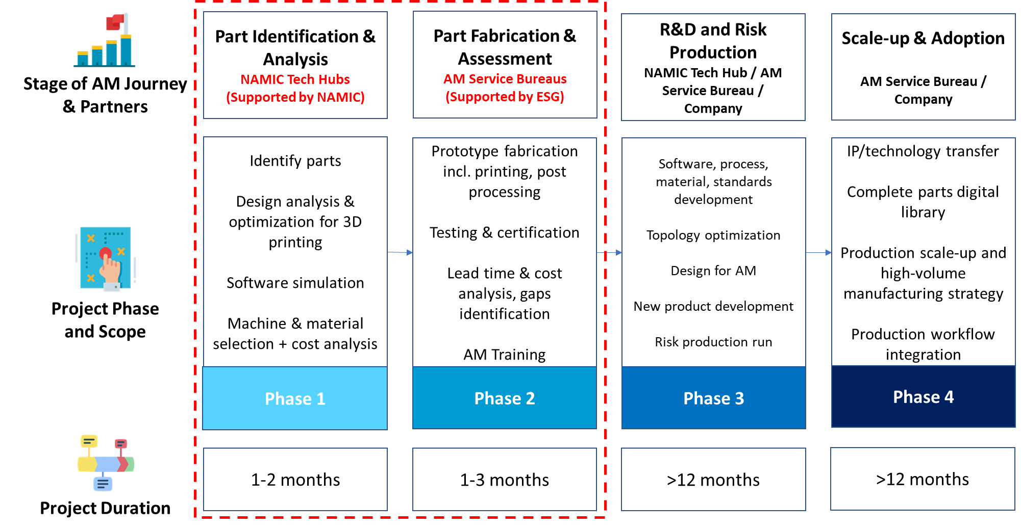

Figure 1. Enterprise’s AM Journey and details of support under the initiative

ANNEX B: Proposal Template

Open Grant Call for
Parts Analysis and Design for Additive Manufacturing

Proposal Template

TITLE OF PROJECT

Project Team:
Name, Designation, Organisation
Name, Designation, Organisation

- Overview
Please provide a clear outline of your proposed project. Describe your company business, the parts, and the challenges that you plan to address with AM.

- Proposal Description
Treat this section as a way to elaborate on your project. Provide the technical details of selected parts (i.e. weight & dimension, functionality, finishing requirement, material, mechanical properties (if any), etc.), and also the economics of the parts produced with conventional manufacturing methods (e.g. cost per part, lead-time, number of parts needed annually, name and location of the manufacturer, inventory cost, supply chain risk, etc.).
Please fill in the part information using the below table.
Part name:  Current manufacturing method:  Current manufacturer and its location:  Functionality: |  | [Insert product image or CAD illustration]
Technical Details | Reference Specs /Target | Challenges
Dimension (LxWxH)
Weight (g)
Accuracy (um)
Surface finishing (um)
Mechanical properties target (e.g. hardness, tensile strength, etc.)
Material
Economic Factors | Reference Specs /Target | Challenges
Cost/ part (incl. post processing)
Lead time/ part (incl. pre & post process)
Inventory cost/ part
Supply chain risk
Obsolete parts? (Yes/No)
High complexity? (Yes/No)
Does the part require multiple assembly process? (Yes/No)
Does your company own the product/ design IP? (Yes/No)

- Project Team and Company Background
Please divide into 2 sections. First section describes the background of the main applicant (end-user company) and the project team members, together with their respective role in the project. Please also include the list of documents needed for company’s eligibility verification in Annex B-3. Second section elaborates the AM service provider (please contact NAMIC if referral for AM service provider is needed). Company information should include following:
- Company is established in (YEAR)
- Nature of business
  - Core service:
  - Core products:
  - Exclusive deals or awards:
  - Overseas presence & proportion of sales turnover:
  - Other notable aspects of Company
- Current top revenue streams
- Brief background of founders/management
- 2-3 characteristics of the nature your industry
- Name key customers and competitors
- List the next development & growth plans/directions

- Deliverables, Milestones and Decision Points
Please indicate the estimated timeline for each phase using a Gantt chart.
Activities/Deliverables | Estimated timeline (in weeks/months)
Phase 1. Deliverable is the feasibility assessment report of the selected parts.
Phase 2. Deliverables are the 3D- printed prototypes and a final report on analysis and evaluation outcomes.

- Budget Estimation and Funding Requested
Please provide the estimated costs in Annex B-1 & Annex B-2 for Phase 1 and Phase 2 respectively. Explain what will be provided by each party involved in this project.

- Schematics & other supporting information [optional]
Please provide any schematics, diagrams or tables that help support or clarify your project. Please ensure that these are clearly labelled and will be legible when printed on A4 paper and in black and white.

ANNEX B-1: In-kind contribution by Company for Phase 1
In-kind contribution by Company
Manpower
Please breakdown the details  E.g. 1x Engineer – 10 manhours | $500
OOE/Equipment
Please breakdown the details  E.g. Use of test equipment e.g. EDX, microscope – 2 hours | $150
Total

ANNEX B-2: Breakdown of Project Budget for Phase 2
Please attach relevant quotations from AM service providers for the cost estimation of the project items. Please contact NAMIC if referral for AM technology providers/service bureaus is needed.

Fabrication Cost i.e. Printing & Post-processing
Description | Unit Cost (S$) | Quantity | Cost (S$)

Testing, Inspection and Certification
Description | Unit Cost (S$) | Quantity | Cost (S$)

AM Training
Description | Unit Cost (S$) | Quantity | Cost (S$)

Consultancy Fee
Description | Unit Cost (S$) | Quantity | Cost (S$)

ANNEX B-3: List of Documents Needed for Company’s Eligibility Verification
Please attach the below supporting documents for ESG’s evaluation:
- Latest ACRA search or instant information. If there are corporate shareholders, please provide the information for the corporate parents as well.
- Audited financial statements or certified management accounts for the last 3 Financial Years (FY) of your company and consolidated financial statements for the last 3 FYs of your ultimate parent company, if applicable.

ANNEX C: Frequently Asked Questions (FAQ)

Q1: What are the eligibility criteria to apply for this grant call?
Companies keen to apply for this initiative should meet the eligibility criteria for the Enterprise Development Grant (EDG), as follows:
- Be registered and operating in Singapore
- Have a minimum of 30% local shareholding
- Be in a financially viable position to start and complete the project

For more information, please visit Enterprise Singapore’s programme page.

Q2: What is the Enterprise Development Grant (EDG)? Is there a specific budget cap?
The Enterprise Development Grant (EDG) helps Singapore companies to grow and transform. This grant supports projects that help you upgrade your business, innovate, or venture overseas.
EDG shall defray up to 80%* of the qualifying costs of the project. The total qualifiable project costs will be capped at S$40,000 per project. Qualifiable cost components include costs for parts printing, post processing, parts testing & qualification, training, and consultancy fees.
The remaining costs shall be borne by the applicant and/or service bureau partner.
*As announced at Budget 2021, the enhanced maximum support level of up to 80% will be extended from 30 September 2021 to 31 March 2022.

Q3: Can I apply for Phase 2 directly?
No, all projects will be required to go through Phase 1.
Progression to Phase 2 will be contingent on the success of Phase 1, as well as written support from NAMIC.

Q4: Can the work be conducted outside Singapore?
All the work should be conducted locally unless the required services are not available in Singapore.

Q5: Is there a maximum number of proposals that a company can submit?
The company can submit more than one proposal. However, the distinct objective, problem statement, and scopes of each proposal need to be clearly outlined.

Q6: Can the proposal consist of more than one company?

Yes. However, only one company needs to apply as the lead/main applicant that will receive the grant.

Q7: Can an AM service provider be involved in Phase 1 together with NAMIC Tech Hubs?
No, Phase 1 work involving parts diagnostics will be performed by one of the NAMIC Tech Hubs. Before the proposal is submitted to NAMIC, there should be some level of part analysis and diagnostics performed by the AM Service Provider to assess if the parts are printable. At the end of Phase 1, there will be a meeting between the AM Service Provider, NAMIC Tech Hub and the SME to review the outcomes (i.e. the print strategy and price quotation for Phase 2), and discuss any discrepancy that may arise.

Q8: Is there a list of AM service providers that the lead applicant needs to work with?

The lead applicant can identify and work with any local AM service provider of their choice. If you require a referral, please contact NAMIC officer (Ms. Tan Hui Qi) via email or visit NAMIC’s AM business directory portal to identify a suitable partner.

Q9: What does AM Training in Phase 2 encompass?
The applicant company may define the scope of the AM training with their AM service providers based on their needs. This may include one or more of the following topics: AM introductory course, Design for AM (DfAM) course, AM process and machine operation training, etc.

Q10: How does the grant reimbursement process work?
All records of expenditure and supporting documents should be provided to ESG within 6 months from project end date. All deliverables in Phase 2 must be achieved upon review by ESG and NAMIC.

